/What is Exception in Java?

**Dictionary Meaning:** Exception is an abnormal condition.

In Java, an exception is an event that disrupts the normal flow of the program. It is an object which is thrown at runtime.

## What is Exception Handling?

Exception Handling is a mechanism to handle runtime errors such as ClassNotFoundException, IOException, SQLException, RemoteException, etc.

### **Advantage of Exception Handling**

The core advantage of exception handling is **to maintain the normal flow of the application**. An exception normally disrupts the normal flow of the application; that is why we need to handle exceptions. Let's consider a scenario:

1. statement 1;
2. statement 2;
3. statement 3;
4. statement 4;
5. statement 5;//exception occurs
6. statement 6;
7. statement 7;
8. statement 8;
9. statement 9;
10. statement 10;

Suppose there are 10 statements in a Java program and an exception occurs at statement 5; the rest of the code will not be executed, i.e., statements 6 to 10 will not be executed. However, when we perform exception handling, the rest of the statements will be executed. That is why we use exception handling in [Java](https://www.javatpoint.com/java-tutorial).

## Hierarchy of Java Exception classes

The java.lang.Throwable class is the root class of Java Exception hierarchy inherited by two subclasses: Exception and Error. The hierarchy of Java Exception classes is given below:

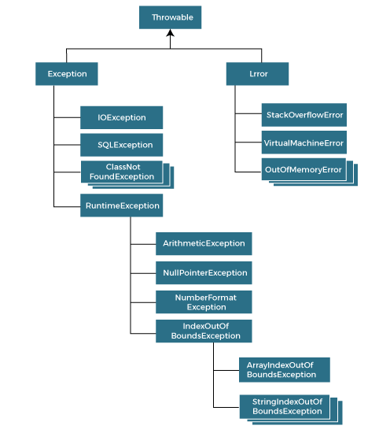

### **Types of Java Exceptions**

There are mainly two types of exceptions: checked and unchecked. An error is considered as the unchecked exception. However, according to Oracle, there are three types of exceptions namely:

1. Checked Exception
2. Unchecked Exception
3. Error

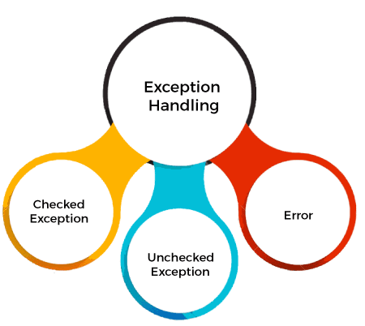

AD

## Difference between Checked and Unchecked Exceptions

### **1) Checked Exception**

The classes that directly inherit the Throwable class except RuntimeException and Error are known as checked exceptions. For example, IOException, SQLException, etc. Checked exceptions are checked at compile-time.

### **2) Unchecked Exception**

The classes that inherit the RuntimeException are known as unchecked exceptions. For example, ArithmeticException, NullPointerException, ArrayIndexOutOfBoundsException, etc. Unchecked exceptions are not checked at compile-time, but they are checked at runtime.

### **3) Error**

Error is irrecoverable. Some example of errors are OutOfMemoryError, VirtualMachineError, AssertionError etc.

## Java Exception Keywords

Java provides five keywords that are used to handle the exception. The following table describes each.

|  |  |
| --- | --- |
| **Keyword** | **Description** |
| try | The "try" keyword is used to specify a block where we should place an exception code. It means we can't use try block alone. The try block must be followed by either catch or finally. |
| catch | The "catch" block is used to handle the exception. It must be preceded by try block which means we can't use catch block alone. It can be followed by finally block later. |
| finally | The "finally" block is used to execute the necessary code of the program. It is executed whether an exception is handled or not. |
| throw | The "throw" keyword is used to throw an exception. |
| throws | The "throws" keyword is used to declare exceptions. It specifies that there may occur an exception in the method. It doesn't throw an exception. It is always used with method signature. |

## Java Exception Handling Example

Let's see an example of Java Exception Handling in which we are using a try-catch statement to handle the exception.

**JavaExceptionExample.java**

1. **public** **class** JavaExceptionExample{
2. **public** **static** **void** main(String args[]){
3. **try**{
4. //code that may raise exception
5. **int** data=100/0;
6. }**catch**(ArithmeticException e){System.out.println(e);}
7. //rest code of the program
8. System.out.println("rest of the code...");
9. }
10. }

[**Test it Now**](https://www.javatpoint.com/opr/test.jsp?filename=JavaExceptionExample)

**Output:**

Exception in thread main java.lang.ArithmeticException:/ by zero

rest of the code...

In the above example, 100/0 raises an ArithmeticException which is handled by a try-catch block.

AD

AD

## Common Scenarios of Java Exceptions

There are given some scenarios where unchecked exceptions may occur. They are as follows:

### **1) A scenario where ArithmeticException occurs**

If we divide any number by zero, there occurs an ArithmeticException.

1. **int** a=50/0;//ArithmeticException

### **2) A scenario where NullPointerException occurs**

If we have a null value in any [variable](https://www.javatpoint.com/java-variables), performing any operation on the variable throws a NullPointerException.

1. String s=**null**;
2. System.out.println(s.length());//NullPointerException

### **3) A scenario where NumberFormatException occurs**

If the formatting of any variable or number is mismatched, it may result into NumberFormatException. Suppose we have a [string](https://www.javatpoint.com/java-string) variable that has characters; converting this variable into digit will cause NumberFormatException.

1. String s="abc";
2. **int** i=Integer.parseInt(s);//NumberFormatException

### **4) A scenario where ArrayIndexOutOfBoundsException occurs**

When an array exceeds to it's size, the ArrayIndexOutOfBoundsException occurs. there may be other reasons to occur ArrayIndexOutOfBoundsException. Consider the following statements.

AD

1. **int** a[]=**new** **int**[5];
2. a[10]=50; //ArrayIndexOutOfBoundsException

# **Java try-catch block**

## Java try block

Java **try** block is used to enclose the code that might throw an exception. It must be used within the method.

If an exception occurs at the particular statement in the try block, the rest of the block code will not execute. So, it is recommended not to keep the code in try block that will not throw an exception.

Java try block must be followed by either catch or finally block.

### **Syntax of Java try-catch**

1. **try**{
2. //code that may throw an exception
3. }**catch**(Exception_class_Name ref){}

### **Syntax of try-finally block**

1. **try**{
2. //code that may throw an exception
3. }**finally**{}

## Java catch block

Java catch block is used to handle the Exception by declaring the type of exception within the parameter. The declared exception must be the parent class exception ( i.e., Exception) or the generated exception type. However, the good approach is to declare the generated type of exception.

The catch block must be used after the try block only. You can use multiple catch block with a single try block.

## Internal Working of Java try-catch block

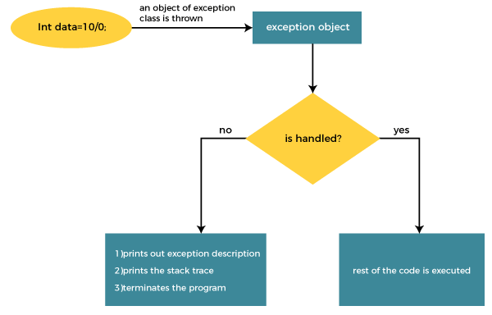

The JVM firstly checks whether the exception is handled or not. If exception is not handled, JVM provides a default exception handler that performs the following tasks:

* Prints out exception description.
* Prints the stack trace (Hierarchy of methods where the exception occurred).
* Causes the program to terminate.

But if the application programmer handles the exception, the normal flow of the application is maintained, i.e., rest of the code is executed.

Java Multi-catch block

A try block can be followed by one or more catch blocks. Each catch block must contain a different exception handler. So, if you have to perform different tasks at the occurrence of different exceptions, use java multi-catch block.

Points to remember

* At a time only one exception occurs and at a time only one catch block is executed.
* All catch blocks must be ordered from most specific to most general, i.e. catch for ArithmeticException must come before catch for Exception.

# **Java finally block**

**Java finally block** is a block used to execute important code such as closing the connection, etc.

Java finally block is always executed whether an exception is handled or not. Therefore, it contains all the necessary statements that need to be printed regardless of the exception occurs or not.

The finally block follows the try-catch block.

### **Flowchart of finally block**

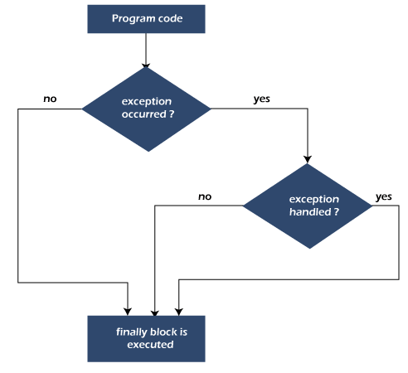

#### **Note: If you don't handle the exception, before terminating the program, JVM executes finally block (if any).**

## Why use Java finally block?

* finally block in Java can be used to put "**cleanup**" code such as closing a file, closing connection, etc.
* The important statements to be printed can be placed in the finally block.

# **Java Exception Propagation**

An exception is first thrown from the top of the stack and if it is not caught, it drops down the call stack to the previous method. If not caught there, the exception again drops down to the previous method, and so on until they are caught or until they reach the very bottom of the call stack. This is called exception propagation.

# **Java throws keyword**

The **Java throws keyword** is used to declare an exception. It gives an information to the programmer that there may occur an exception. So, it is better for the programmer to provide the exception handling code so that the normal flow of the program can be maintained.

Exception Handling is mainly used to handle the checked exceptions. If there occurs any unchecked exception such as NullPointerException, it is programmers' fault that he is not checking the code before it being used.

### **Syntax of Java throws**

1. return_type method_name() **throws** exception_class_name{
2. //method code
3. }

### **Which exception should be declared?**

**Ans:** Checked exception only, because:

* **unchecked exception:** under our control so we can correct our code.
* **error:** beyond our control. For example, we are unable to do anything if there occurs VirtualMachineError or StackOverflowError.

### **Advantage of Java throws keyword**

Now Checked Exception can be propagated (forwarded in call stack).

It provides information to the caller of the method about the exception.

# **Java throw Exception**

In Java, exceptions allows us to write good quality codes where the errors are checked at the compile time instead of runtime and we can create custom exceptions making the code recovery and debugging easier.

## Java throw keyword

The Java throw keyword is used to throw an exception explicitly.

We specify the **exception** object which is to be thrown. The Exception has some message with it that provides the error description. These exceptions may be related to user inputs, server, etc.

We can throw either checked or unchecked exceptions in Java by throw keyword. It is mainly used to throw a custom exception. We will discuss custom exceptions later in this section.

We can also define our own set of conditions and throw an exception explicitly using throw keyword. For example, we can throw ArithmeticException if we divide a number by another number. Here, we just need to set the condition and throw exception using throw keyword.

The syntax of the Java throw keyword is given below.

throw Instance i.e.,

1. **throw** **new** exception_class("error message");

Let's see the example of throw IOException.

1. **throw** **new** IOException("sorry device error");

Where the Instance must be of type Throwable or subclass of Throwable. For example, Exception is the sub class of Throwable and the user-defined exceptions usually extend the Exception class.

# **Difference between throw and throws in Java**

The throw and throws is the concept of exception handling where the throw keyword throw the exception explicitly from a method or a block of code whereas the throws keyword is used in signature of the method.

There are many differences between [throw](https://www.javatpoint.com/throw-keyword) and [throws](https://www.javatpoint.com/throws-keyword-and-difference-between-throw-and-throws) keywords. A list of differences between throw and throws are given below:

|  |  |  |  |
| --- | --- | --- | --- |
| **Sr. no.** | **Basis of Differences** | **throw** | **throws** |
| 1. | Definition | Java throw keyword is used throw an exception explicitly in the code, inside the function or the block of code. | Java throws keyword is used in the method signature to declare an exception which might be thrown by the function while the execution of the code. |
| 2. | Type of exception Using throw keyword, we can only propagate unchecked exception i.e., the checked exception cannot be propagated using throw only. | Using throws keyword, we can declare both checked and unchecked exceptions. However, the throws keyword can be used to propagate checked exceptions only. |  |
| 3. | Syntax | The throw keyword is followed by an instance of Exception to be thrown. | The throws keyword is followed by class names of Exceptions to be thrown. |
| 4. | Declaration | throw is used within the method. | throws is used with the method signature. |
| 5. | Internal implementation | We are allowed to throw only one exception at a time i.e. we cannot throw multiple exceptions. | We can declare multiple exceptions using throws keyword that can be thrown by the method. For example, main() throws IOException, SQLException. |

# **Exception Handling with Method Overriding in Java**

There are many rules if we talk about method overriding with exception handling.

Some of the rules are listed below:

* **If the superclass method does not declare an exception**
  + If the superclass method does not declare an exception, subclass overridden method cannot declare the checked exception but it can declare unchecked exception.
* **If the superclass method declares an exception**
  + If the superclass method declares an exception, subclass overridden method can declare same, subclass exception or no exception but cannot declare parent exception.

# **Difference between final, finally and finalize**

The final, finally, and finalize are keywords in Java that are used in exception handling. Each of these keywords has a different functionality. The basic difference between final, finally and finalize is that the [**final**](https://www.javatpoint.com/final-keyword) is an access modifier, [**finally**](https://www.javatpoint.com/finally-block-in-exception-handling) is the block in Exception Handling and [**finalize**](https://www.javatpoint.com/java-object-finalize-method) is the method of object class.

Along with this, there are many differences between final, finally and finalize. A list of differences between final, finally and finalize are given below:

|  |  |  |  |  |
| --- | --- | --- | --- | --- |
| **Sr. no.** | **Key** | **final** | **finally** | **finalize** |
| 1. | Definition | final is the keyword and access modifier which is used to apply restrictions on a class, method or variable. | finally is the block in Java Exception Handling to execute the important code whether the exception occurs or not. | finalize is the method in Java which is used to perform clean up processing just before object is garbage collected. |
| 2. | Applicable to | Final keyword is used with the classes, methods and variables. | Finally block is always related to the try and catch block in exception handling. | finalize() method is used with the objects. |
| 3. | Functionality | (1) Once declared, final variable becomes constant and cannot be modified. (2) final method cannot be overridden by sub class. (3) final class cannot be inherited. | (1) finally block runs the important code even if exception occurs or not. (2) finally block cleans up all the resources used in try block | finalize method performs the cleaning activities with respect to the object before its destruction. |
| 4. | Execution | Final method is executed only when we call it. | Finally block is executed as soon as the try-catch block is executed.  It's execution is not dependant on the exception. | finalize method is executed just before the object is destroy |

[**Java Regex**](https://www.javatpoint.com/java-regex)

## Exception Handling

[Java Exceptions](https://www.javatpoint.com/exception-handling-in-java)[Java Try-catch block](https://www.javatpoint.com/try-catch-block)[Java Multiple Catch Block](https://www.javatpoint.com/multiple-catch-block-in-java)[Java Nested try](https://www.javatpoint.com/nested-try-block)[Java Finally Block](https://www.javatpoint.com/finally-block-in-exception-handling)[Java Throw Keyword](https://www.javatpoint.com/throw-keyword)[Java Exception Propagation](https://www.javatpoint.com/exception-propagation)[Java Throws Keyword](https://www.javatpoint.com/throws-keyword-and-difference-between-throw-and-throws)[Java Throw vs Throws](https://www.javatpoint.com/difference-between-throw-and-throws-in-java)[Final vs Finally vs Finalize](https://www.javatpoint.com/difference-between-final-finally-and-finalize)[Exception Handling with Method Overriding](https://www.javatpoint.com/exception-handling-with-method-overriding)[**Java Custom Exceptions** [open link](https://www.javatpoint.com/custom-exception)](https://www.javatpoint.com/custom-exception)[Exception Hand. quiz-1](https://www.javatpoint.com/directload.jsp?val=89)[Exception Hand. quiz-2](https://www.javatpoint.com/directload.jsp?val=96)[Exception Hand. quiz-3](https://www.javatpoint.com/directload.jsp?val=101)

[**Java Inner classes**](https://www.javatpoint.com/java-inner-class)[**Java Multithreading**](https://www.javatpoint.com/multithreading-in-java)[**Java I/O**](https://www.javatpoint.com/java-io)[**Java Networking**](https://www.javatpoint.com/java-networking)[**Java AWT**](https://www.javatpoint.com/java-awt)[**Java Swing**](https://www.javatpoint.com/java-swing)[**JavaFX**](https://www.javatpoint.com/javafx-tutorial)[**Java Applet**](https://www.javatpoint.com/java-applet)[**Java Reflection**](https://www.javatpoint.com/java-reflection)[**Java Date**](https://www.javatpoint.com/java-date)[**Java Conversion**](https://www.javatpoint.com/java-string-to-int)[**Java Collection**](https://www.javatpoint.com/collections-in-java)[**Java JDBC**](https://www.javatpoint.com/java-jdbc)[**Java New Features**](https://www.javatpoint.com/New-features-in-java)[**RMI**](https://www.javatpoint.com/RMI)[**Internationalization**](https://www.javatpoint.com/internationalization-in-java)[**Interview Questions**](https://www.javatpoint.com/corejava-interview-questions)

JavaTpoint

|  |
| --- |
| [**Next →**](https://www.javatpoint.com/java-inner-class)[**← Prev**](https://www.javatpoint.com/exception-handling-with-method-overriding) **Java Custom Exception** In Java, we can create our own exceptions that are derived classes of the Exception class. Creating our own Exception is known as custom exception or user-defined exception. Basically, Java custom exceptions are used to customize the exception according to user need.  Consider the example 1 in which InvalidAgeException class extends the Exception class.  Using the custom exception, we can have your own exception and message. Here, we have passed a string to the constructor of superclass i.e. Exception class that can be obtained using getMessage() method on the object we have created.  In this section, we will learn how custom exceptions are implemented and used in Java programs. Why use custom exceptions? Java exceptions cover almost all the general type of exceptions that may occur in the programming. However, we sometimes need to create custom exceptions.  Following are few of the reasons to use custom exceptions:   * To catch and provide specific treatment to a subset of existing Java exceptions. * Business logic exceptions: These are the exceptions related to business logic and workflow. It is useful for the application users or the developers to understand the exact problem. |